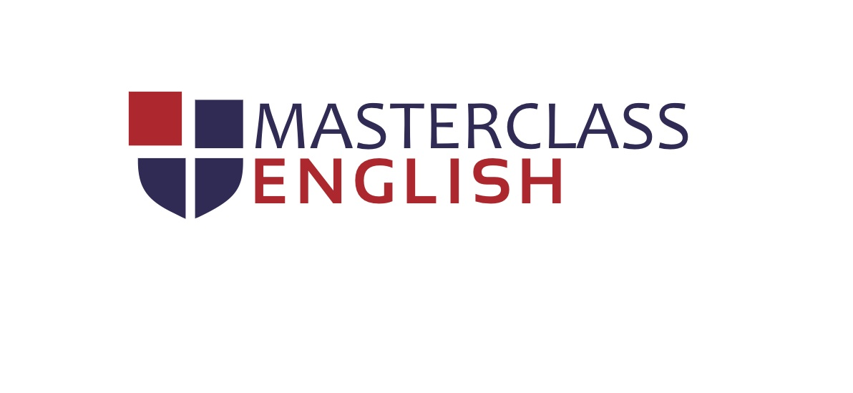 | Masterclass Academy of Languages  Centre Number NL072  Tel: 010-7532038  cambridge@masterclassenglish.com

CONSENT FORM
for candidates aged 17 and under

To be completed by the parents/legal guardian of all candidates aged 17 and under

I am the parent / legal guardian of:

Candidate name

Candidate date of birth

Examination taken

Declaration:
I am the parent/legal guardian of the candidate named on this form and I give consent to this person taking the
Cambridge English exam selected above.
I understand that all individuals who want to take a Cambridge English exam are required to agree to all of the
Terms and Conditions. I agree to the candidate being admitted for the selected Cambridge English exam at the centre listed on this form and for the date listed here. The candidate will bring a non-expired original photo ID with them on the test day.
I consent to them having their photo taken by the centre on the day of the Speaking test and/or the written papers. I agree for this photo to be held on the secure Cambridge English Language Assessment Results Verification site and viewed as set out below if I give my agreement on behalf of the candidate. The photo shall only be available to organisations/individuals that I agree to Cambridge English Language Assessment giving the candidate’s details to or authorise to view the candidate’s result.
In addition, I understand that I also provide consent for my son/daughter to leave the exam premises by him/herself at the end of the test day.

By signing this form I declare that I am aware of and agree to comply with the Terms and Conditions for this exam.

Parent/legal guardian name

Parent/legal guardian signature

Date

